Section 1 — Introduction
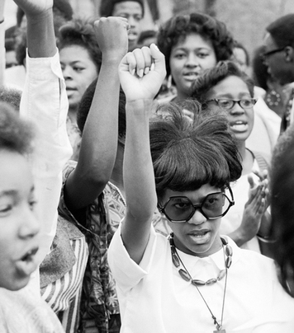
Flip Schulke/Corbis

In 1966, James Meredith, the first African American graduate of the University of Mississippi, began a campaign he called his March Against Fear. He planned to walk from Memphis, Tennessee, to Jackson, Mississippi. Along the way he hoped to encourage the African Americans he met to stand up for their rights by registering to vote. Only 30 miles out of Memphis, Meredith was shot by a sniper. He survived but was hospitalized.

A number of civil rights leaders stepped up to complete Meredith’s march. Among them were Dr. Martin Luther King Jr. and Stokely Carmichael, the young leader of the Student Nonviolent Coordinating Committee (SNCC). On their first day, an angry policeman knocked King down. Carmichael prepared to retaliate, only to be stopped by other marchers. Rather than thanking Carmichael, King scolded him for straying from the strategy of nonviolence. In Carmichael’s view, this incident had little to do with nonviolence. “It was,” he insisted, “about self-defense.”

For days the marchers endured insults and threats from angry whites. When they reached Greenwood, Mississippi, Carmichael was arrested while trying to set up a tent for the night. “By the time I got out of jail,” he recalled, “I was in no mood to compromise with racist arrogance.” The night of his release, Carmichael addressed a rally in Greenwood. “It’s time we stand up and take over,” he said. “We been saying freedom for six years and we ain’t got nothin’. What we gonna start saying now is black power.” Again and again he asked the crowd, “What do you want?” Each time the crowd roared back, “Black power!”

Carmichael’s speech and the crowd’s response reflected a turning point in the civil rights movement. For more than 10 years, the movement’s leaders had favored nonviolence as their main strategy and integration as their primary goal. With his talk of black power, Carmichael was signaling a change in what many blacks wanted and how they would achieve these new goals.

Section 2 — The Nation's Black Ghettos Explode

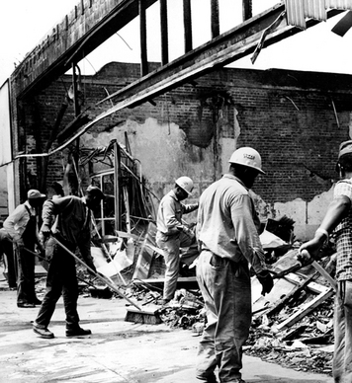
In 1965, Watts, a black neighborhood in Los Angeles, exploded in six days of rioting. The violence left large parts of Watts in ruins. Here, workers clean up the damage from a burned building. Keystone/Getty Images
In 1963, the African American writer James Baldwin published an essay on what it was like to be black in the United States. Baldwin reminded his readers that blacks had waited far too long for equality. If the United States did not live up to its ideals soon, he warned, the result could be an eruption of violence.

If we—and now I mean the relatively conscious whites and the relatively conscious blacks . . . do not falter in our duty now, we may be able, handful that we are, to end the racial nightmare . . . If we do not now dare everything, the fulfillment of that prophecy, re-created from the Bible in song by a slave, is upon us: God gave Noah the rainbow sign, No more water, the fire next time!
—James Baldwin, The Fire Next Time, 1963

Fire did indeed erupt, as anger increased over the slow pace of progress and the federal government’s weak support for civil rights.Beginning in 1964, African Americans lashed out in violent protests in cities across the country.

From Watts to Newark: Riots in the Streets
By the 1960s, almost 70 percent of African Americans lived in large cities. Urban blacks were often concentrated in ethnic ghettos. A ghetto is a part of a city where people belonging to a single ethnic group live. Sometimes people live in an ethnic ghetto because they want to be among people who share their culture. But often people live in such neighborhoods because social and economic conditions prevent them from moving elsewhere. This was true for African Americans. Because of job discrimination, many could not afford to live anywhere else. Even those with good jobs found it almost impossible to buy houses in white neighborhoods.

In August 1965, a race riot exploded in Watts, an African American ghetto in Los Angeles. The immediate cause of the riot was a charge of police brutality. The more long-term cause was African Americans’ festering frustrations about poverty, prejudice, and police mistreatment.

The Watts riot lasted for six long days. During that time, 34 people died, almost 900 were injured, and nearly 4,000 were arrested. Rioters burned and looted whole neighborhoods, causing $45 million of property damage. The rioting did not end until 14,000 members of the National Guard were sent to Watts to restore order.
Over the next few years, riots erupted in other cities as well. In 1967 alone, more than 100 cities experienced violent protests. In Detroit, Michigan, 43 people died and more than 1,000 were wounded in an urban upheaval. Eventually the army quelled the riots by sending in tanks and soldiers with machine guns. Riots in Newark, New Jersey lasted six days and resulted in many deaths and injuries.

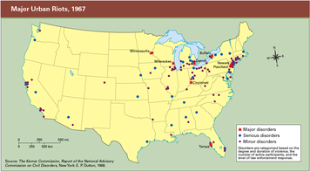
Beginning with rioting in Harlem and Rochester, New York, in 1964, racial unrest spread out of the North to cities across the nation. This map show major riots in 1967. Other disturbances also occurred that year. The murder of Martin Luther King Jr. in 1968 triggered the worst violence of the decade. After that, racial unrest subsided.

The Kerner Commission Report: Moving Toward Two Societies
It was not until 1967, in response to the rioting that summer, that President Lyndon Johnson, also known as LBJ, established the National Advisory Commission on Civil Disorders to examine what had caused the riots. The commission came to be known as the Kerner Commission after its leader, Illinois governor Otto Kerner. Its final report, issued in 1968, concluded that “Our nation is moving toward two societies, one black, one white—separate and unequal.”
Looking deeper, the report found that riots were usually triggered by a specific event that touched off a “reservoir of underlying grievances”:
Social and economic conditions in the riot cities constituted a clear pattern of severe disadvantage for Negroes compared with whites . . . Negroes had completed fewer years of education and fewer had attended high school. Negroes were twice as likely to be unemployed . . . and were more than twice as likely to be living in poverty. Although housing cost Negroes relatively more, they had worse housing—three times as likely to be overcrowded and substandard.
—National Advisory Commission on Civil Disorders, 1968
The report pointed to “unfulfilled expectations” raised by the civil rights movement. When these expectations were not met, some African Americans had concluded that violence was the only way to “move the system.”
The commission called on the country to address the inequalities that the riots had laid bare. “It is time now to turn with all the purpose at our command to the major unfinished business of this nation,” it urged. “It is time to make good the promises of American democracy to all citizens—urban and rural, white and black, Spanish-surname, American Indian, and every minority group.”

Section 3 — The Rise of Black Power and Black Pride
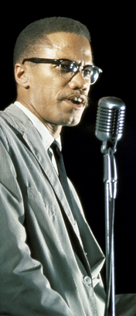
As a Black Muslim minister, Malcolm X supported black nationalism. He said, “The only way the black people who are in this society can be saved is not to integrate into this corrupt society but separate ourselves from it, reform ourselves, lift up our moral standards and try and be godly.” Later he broke with the Black Muslims and made a broad, nonracial appeal for human rights. Robert Parent-Time Life Pictures/Getty Images
After the Watts riot, Martin Luther King Jr. visited Los Angeles to find out what had happened and why. While touring Watts, King was booed by residents who had lost faith in his strategy and goals. Nonviolent resistance had eroded barriers to integration in the South. But these victories had taken 10 years, and many urban blacks were impatient for change. They were also not sure they wanted to be integrated into a white society that they viewed as racist and corrupt. As activism spread beyond the South, the civil rights movement was changing.

Malcolm X Advocates Black Nationalism
One of the leaders of this change was a former convict named Malcolm X. Born in 1925 as Malcolm Little, Malcolm X drifted into a life of crime during his teenage years. Eventually he was arrested and jailed. In prison, he was introduced to the teachings of Elijah Muhammad, the leader of a religious group known as theNation of Islam, or Black Muslims. Muhammad taught that blacks were Earth’s first people but had been tricked out of their power and long oppressed by evil whites. Malcolm X later wrote of the appeal of Muhammad’s teachings to African American convicts:

Here is a black man caged behind bars, probably for years, put there by the white man . . . You let this caged up black man start thinking, the same way I did when I first heard Elijah Muhammad’s teachings: let him start thinking how, with better breaks when he was young and ambitious he might have been a lawyer, a doctor, a scientist, anything . . . That’s why black prisoners become Muslims so fast when Elijah Muhammad’s teachings filter into their cages . . . “The white man is the devil” is a perfect echo of that black convict’s lifelong experience.
—Malcolm X, The Autobiography of Malcolm X, 1964

After Malcolm Little left prison in 1952, he joined the Nation of Islam and changed his name to Malcolm X. He said Little was the name of a white slave-owner. He chose X as his new last name because “a Negro in America can never know his true family name, or even what tribe he was descended from.” He quickly became the Nation of Islam’s most effective preacher. In 1959, he was featured in a weeklong television special called The Hate That Hate Produced, which brought widespread attention to Malcolm and the Nation of Islam.

As a Black Muslim, Malcolm X rejected the goals of the early civil rights movement. Rather than seeking integration, the Nation of Islam promoted black nationalism, a doctrine that called for complete separation from white society. Black Muslims worked to become independent from whites by establishing their own businesses, schools, and communities.
Malcolm X also rejected nonviolence as a strategy to bring about change. Speaking to a group of black teenagers in New York City in 1964, he said, If the leaders of the nonviolent movement can go to the white community and teach nonviolence, good. I’d go along with that. But as long as I see them teaching nonviolence only in the black community, we can’t go along with that . . . If black people alone are going to be the ones who are nonviolent, then it’s not fair. We throw ourselves off guard. In fact, we disarm ourselves and make ourselves defenseless.

By the time he made this speech, Malcolm X had split with the Nation of Islam. During a pilgrimage to the Muslim holy city of Mecca in 1964, he had met Muslims of all races, including “blonde-haired, blued-eyed men I could call my brothers.” On his return home, Malcolm X converted to orthodox Islam and began to reach out to people of all races, making a broader call for human rights. His change of heart upset many Black Muslims. In 1965, three members of the Nation of Islam assassinated Malcolm X while he was speaking in New York City.
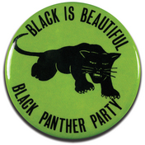
The Black Panthers, who were militant black nationalists, called for economic and political equality for African Americans. They dressed in military-style clothing and often carried guns as a symbol of black power. David J. & Janice L. Frent Collection/Corbis

SNCC Stands Up for Black Power
A year after Malcolm X’s death, SNCC leader Stokely Carmichael introduced the idea of black power to the civil rights movement.Black power had a variety of meanings, such as political power, economic power, and pride in being black. In a speech on black power, Carmichael observed that,
This country knows what power is. It knows it very well. And it knows what Black Power is ’cause it deprived black people of it for 400 years. So it knows what Black Power is . . . We are on the move for our liberation . . . The question is, Will white people overcome their racism and allow for that to happen in this country? If that does not happen, brothers and sisters, we have no choice but to say very clearly, “Move over, or we’re going to move on over you.”
—Stokely Carmichael, speech in Berkeley, California, 1966
Carmichael went on to convert SNCC from an integrated organization to an all-black organization.“We cannot have white people working in the black community,” he argued. “Black people must be seen in positions of power, doing and articulating [speaking] for themselves.”

Black Panthers Work for Self-Determination
Among the many African Americans influenced by Malcolm X were Bobby Seale and Huey Newton.In 1966, they founded the Black Panther Party in Oakland, California. In choosing that name, the founders were sending the world a message. An early supporter explained, “The black panther was a vicious animal, who, if he was attacked, would not back up. It was a political symbol that we were here to stay and we were going to do whatever needed to be done to survive.”
The Black Panther Party developed a 10-point platform setting out its goals. The first and last points dealt with self-determination. “We want freedom,” the platform began. “We want power to determine the destiny of our Black Community.” Other demands included jobs, decent housing, “education that teaches our true history,” and “an immediate end to police brutality.” Finally, the platform called on the United Nations to supervise a plebiscite among African Americans to determine “the will of black people as to their national destiny.” A plebiscite is a vote on a question of importance.
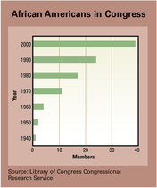
The civil rights movement increased the number of black voters. It also led to increased numbers of African Americans being elected to Congress. When it was founded in 1969, the Congressional Black Caucus had 13 members. By 2005, that number had grown to 43.
The Black Panthers provided many services for blacks in their community, such as free breakfast programs for children, and medical clinics. But they were probably best known for their efforts to end police mistreatment of blacks. They sent observers onto the streets to watch interactions between police and black citizens. The observers carried a law book to provide information about people’s rights, a tape recorder to document what was said, and a shotgun to show that they were prepared to defend themselves.
Because Black Panthers carried weapons and were willing to stand up to the police, they were viewed as dangerous radicals by law enforcement agencies. Local police and FBI agents often raided the Panthers’ offices and homes. When confrontations with the police turned violent, the Panthers involved were arrested and jailed. By the mid-1970s, with its legal problems mounting, the Black Panther Party fell apart.
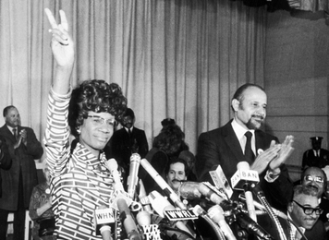
In 1968, Shirley Chisholm became the first black woman elected to Congress. Chisholm was one of a growing number of African Americans elected to political office as a result of the civil rights movement. In 1972, Chisholm ran for president. Don Hogan Charles-New York Times Co./Getty Images

Black Power at the Polls Brings Political Gains
For many African Americans, black power meant the power to shape public policy through the political process. Supported by the Voting Rights Act of 1965, civil rights groups organized voter-registration drives across the South. Between 1964 and 1968, the number of southern blacks registered to vote rose from 1 to 3.1 million.
Across the nation, African American candidates successfully competed for both black and white votes. Edward Brooke of Massachusetts was elected to the Senate in 1966, becoming the first black senator since 1881. Two years later, Shirley Chisholm of New York became the first black woman to win election to the House of Representatives. In 1969, the African American members of the House of Representatives started the Congressional Black Caucus.Over the years, the caucus has worked to address legislative concerns of African American citizens.
Black politicians were also successful at winning state and local elections. In 1967, Carl Stokes of Cleveland, Ohio, became the first black mayor of a major U.S. city. Six years later, Tom Bradley became the first black mayor of Los Angeles. Bradley won by forging a powerful coalition that included inner-city blacks, the Jewish community, and business and labor leaders. “He built bridges to whites and to other groups,” noted a political scientist, “without ever losing his commitment to the black community.” Bradley was reelected four times, serving as mayor for 20 years.
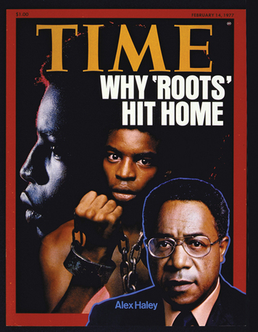
Roots, a television miniseries on slavery, had a huge impact when it aired in 1977. Based on a novel by Alex Haley and starring actor LeVar Burton (shown above), the series told the story of several generations of an enslaved black family. TV executives feared that a show focused on African American history would be a ratings failure. To their surprise, Roots became the most-watched television show in history. Time Magazine, Â© Time Inc.-Time Life Pictures/Getty Images
African Americans also rose in the judicial branch of the government.Thurgood Marshall, who had argued the Brown v. Board of Educationcase as the NAACP’s lead attorney, was named the first black Supreme Court justice in 1967.

Black Pride: The Growth of Afrocentrism
For many African Americans, black power meant taking pride in their African heritage. This focus on African history, African culture, and the achievements of African peoples and their descendants in the United States came to be known as Afrocentrism. Afrocentric scholars argued that the accounts of history taught in most schools ignored the many contributions of African peoples. In their view, Afrocentrism helped to balance the Eurocentric, or European-centered, view of the past that had long been presented to American schoolchildren, both black and white.
African Americans showed pride in their heritage in many ways.College students pushed for the establishment of African and African American studies classes. Museums began to show African American history and art. On a more day-to-day basis, many blacks began to dress in traditional African clothing, wear their hair in African styles called Afros, and exchange their Eurocentric names for Afrocentric ones. In 1966, a black scholar invented an Afrocentric holiday called Kwanzaa, which takes place each year between December 26 and January 1. During Kwanzaa, black Americans celebrate seven principles of African American culture, including faith, creativity, and unity.
Black writers also expanded Afrocentric culture as they wrote about their experiences. Poets like Nikki Giovanni and playwrights like Amiri Baraka and August Wilson brought the struggles of African Americans into their poems and plays. Novelists like Maya Angelou, Toni Morrison, and Alice Walker wrote widely read novels about African American life, both past and present.
In 1977, a 12-hour television miniseries on African American life called Roots became one of the most highly rated shows in television history. Based on a historical novel by Alex Haley, Roots told the story of several generations of an enslaved black family. More than 250 colleges planned courses around the broadcasts, while more than 30 cities declared “Roots” weeks. Vernon Jordan, former president of the Urban League, called the miniseries “the single most spectacular educational experience in race relations in America.”

Section 4 — The Federal Government Confronts Racism
On March 31, 1968, Martin Luther King Jr. preached at the National Cathedral in Washington, D.C. In his sermon, King spoke frankly about racism:
It is an unhappy truth that racism is a way of life for the vast majority of white Americans, spoken and unspoken, acknowledged and denied, subtle and sometimes not so subtle . . .Something positive must be done. Everyone must share in the guilt as individuals and as institutions . . . The hour has come for everybody, for all institutions of the public sector and the private sector to work to get rid of racism.
—Martin Luther King Jr., “Remaining Awake Through a Great Revolution,” 1968
That hour never came for King. Four days later he was assassinated in Memphis, Tennessee, where he had gone to support a sanitation workers’ strike. Riots erupted in more than 100 cities, including Washington, D.C. As dawn broke on April 6, 1968, a thick pall of smoke hung over the nation’s capital. In the wake of these tragedies, the federal government increased its efforts to end racism and discrimination in public life.

Banning Racial Discrimination in Housing
Before his death, King had shifted his focus from integration to economic equality. As part of this campaign, he took on the issue of racial discrimination in housing. In many U.S. cities, landlords in white neighborhoods refused to rent to blacks. African Americans also found it difficult to buy houses in many neighborhoods. Even when African Americans found a home to buy, they discovered that banks were reluctant to make loans to black borrowers.
Under King’s leadership, the black community joined with realtors and bankers to encourage open housing in Chicago. But very little actually changed. Then, in 1968, only days after King’s assassination, Congress finally took action. Drawing on King’s efforts and on the national grief over his death, Congress passed the Civil Rights Act of 1968. This law included a fair-housing component that banned discrimination in housing sales and rentals. It also gave the federal government the authority to file lawsuits against those who violated the law.
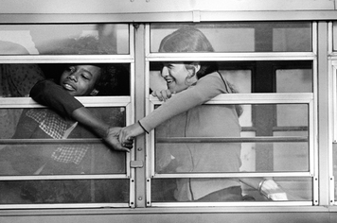
Many school districts used busing to integrate schools. These children are being bused to a Boston school in 1975. NAACP leader Ruth Baston explained that she favored busing because schools in white neighborhoods were better than schools in black neighborhoods. She observed that where “there were a large number of white students, that’s where the care went. That’s where the books went. That’s where the money went.” David J. & Janice L. Frent Collection/Corbis

Desegregating Public Schools
In 1954, the Supreme Court had ruled in Brown v. Board of Educationthat school segregation was unconstitutional. A year later, it had ordered schools to be desegregated “with all deliberate speed.” But a decade later, only 1.2 percent of black children in the South attended integrated schools.
The Civil Rights Act of 1964 gave the federal government new powers to promote school desegregation. Government officials pushed school districts to integrate their schools by threatening to cut off federal funds if they did not. By 1968, the proportion of African American students in the South attending schools with whites had risen to 32 percent.
By this time, however, the Supreme Court was losing patience with school districts that were slow to act. In a 1969 case known as Alexander v. Holmes County Board of Education, the Court took another look at “with all deliberate speed.” The case involved a segregated Mississippi school district that was trying to delay integration. In the Court’s decision, Justice Hugo Black wrote,
There are many places still in this country where the schools are either “white” or “Negro” and not just schools for all children as the Constitution requires. In my opinion there is no reason why such a wholesale deprivation of constitutional rights should be tolerated another minute. I fear that this long denial of constitutional rights is due in large part to the phrase “with all deliberate speed.” I would do away with that phrase completely.
—Alexander v. Holmes County Board of Education, 1969
Three years later, the Supreme Court took another look at school segregation in Swann v.Charlotte-Mecklenburg Board of Education. This case raised the question of whether de facto segregation caused by housing patterns was constitutional. This was the situation in North Carolina’s Charlotte-Mecklenburg School District. Because most children in the district lived in predominantly white or black neighborhoods, they also attended all-white or all-black schools. In 1970, a federal judge ordered the district to use busing to integrate its schools. Under the judge’s desegregation plan, some students, including very young ones, would be bused to schools outside their neighborhoods to create more racially balanced schools.
The school district appealed to the Supreme Court, arguing that the judge had gone too far. In a unanimous decision delivered in 1971, the Court supported the judge’s busing plan. “We find no basis for holding that the local school authorities may not be required to employ bus transportation as one tool of school desegregation,” wrote Chief Justice Warren Burger. “Desegregation plans cannot be limited to walk-in schools.”
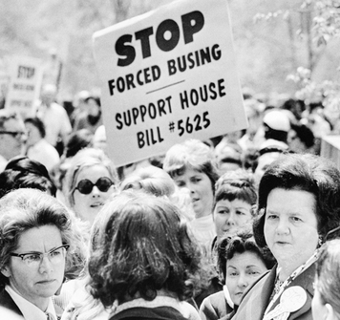
Boston’s efforts to desegregate schools were marred by protests and violence. White families fled the city, resulting in a school population composed mostly of minority students. Bettmann/Corbis

Using Busing to Achieve Racial Balance in Schools
The Court’s approval of busing to achieve racial balance in schools was controversial. Supporters argued that busing was useful for ending school segregation. They quoted studies showing that black children got higher test scores when attending integrated schools.However, many parents, both black and white, felt strongly that their children should attend schools close to home. They worried about the effects of long bus rides, especially on young children. They also feared for the safety of children bused into unfamiliar neighborhoods.

Nowhere was resistance to busing stronger than in the city of Boston, Massachusetts. In 1974, a judge ordered the busing of 17,000 Boston school children to desegregate the city’s schools. Large numbers of white families opposed the judge’s order. Resistance was especially strong in South Boston, a mostly white neighborhood.

When school began at South Boston High School that fall, 90 percent of its white students boycotted classes. Black students leaving the school to board buses back to their neighborhoods were pelted with rocks. Later that fall, a white student was stabbed in a racial confrontation at the school. In response, an angry white mob trapped 135 black students in the school building for four hours. A force of 500 police officers was assigned to South Boston High—which had only 400 students—to keep order.
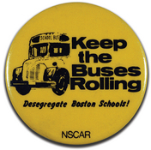
David J. & Janice L. Frent Collection/Corbis
Over the next two years, an estimated 20,000 white students left Boston’s public schools to avoid busing. Some went to private schools. Others moved with their families to the suburbs. As a result, by 1976, blacks and Hispanics made up the majority of Boston’s school population.

Despite public resistance, the courts continued to enforce the Brown decision. By 1976, almost half of black students in the South attended schools with a majority of white students. In the Northeast, only 27.5 percent of black students attended integrated schools.

Fighting Racism in the Workplace Through Affirmative Action
The Civil Rights Act of 1964 had outlawed discrimination in hiring based on race, religion, gender, or national origin. However, many argued that simply “leveling the playing field” in hiring was not enough. As President Lyndon Johnson observed in a speech to graduates of Howard University,

You do not take a person who for years has been hobbled by chains and liberate him, bring him up to the starting line of a race and then say, “you’re free to compete with all the others,” and still justly believe that you have been completely fair. Thus it is not enough just to open the gates of opportunity. All our citizens must have the ability to walk through those gates.
—Lyndon Johnson, Howard University, 1965
Johnson argued that more needed to be done to counteract past discrimination that had denied minorities equal opportunities. One way to do this was through a policy known as affirmative action. This policy called on employers to actively seek to increase the number of minorities in their workforce.
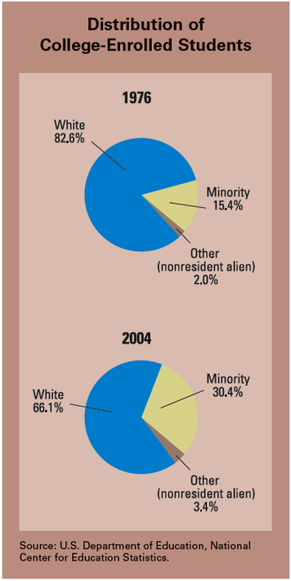
Affirmative action increased the number of minority students attending U.S. colleges and universities. In 1978, the Supreme Court ruled in Regents of the University of California v. Bakke that race could be considered in school admissions. But it could not be the only factor. The term “nonresident alien” in the graphs refers to foreign students.
Affirmative action was first introduced by President John F. Kennedy.In 1961, he issued an executive order that called on contractors doing business with the federal government to “take affirmative action” to hire minorities. President Johnson expanded Kennedy’s policy to include women. He also required contractors to have written affirmative action plans. “This is the next and more profound stage of the battle for civil rights,” Johnson said. “We seek . . . not just equality as a right and a theory, but equality as a fact and as a result.”

President Richard Nixon took affirmative action a giant step further. In an executive order, he required government contractors to develop “an acceptable affirmative action program” that included “goals and timetables.”

Equalizing Opportunities Through Preferential Treatment
Many Americans agree with the goals of affirmative action. However, the practices used to carry out this policy have been controversial. An affirmative action plan may set specific goals, such as numbers of minority or women workers to be hired. It may include a timetable with dates for achieving those goals. It may also prescribe preferential treatment for some groups. This means giving preference to a minority or female job applicant because of that person’s ethnicity or gender.To many people, preferential treatment looks like unfair discrimination against white males.

During the 1960s, many colleges and universities adopted affirmative action plans to attract more minority students. Members of minority groups were often given preferential treatment over white students who were equally qualified or more qualified. Such treatment was necessary, admissions officers argued, to open opportunities for minorities and to create a diverse student body.

In the late 1970s, a white male named Allan Bakke challenged preferential treatment in university admissions. Bakke had twice applied for admission to the University of California Davis Medical School. He was rejected both times. At the same time, minority candidates with lower grade point averages and test scores were admitted under a special admissions program. Bakke concluded that he had been refused admission because he was white, and he sued the school for reverse discrimination.

In 1977, Regents of the University of California v. Bakke reached the Supreme Court. After hearing arguments on both sides, the Court was left deeply divided. Four justices were firmly against any use of race in university admissions. Another four felt just as strongly that race should be used.The remaining justice, Lewis Powell, thought race could be used as a criterion in choosing students but opposed the system of preferential treatment used by the University of California. Writing for the majority, Powell cautioned, “Racial and ethnic classifications of any sort are inherently suspect and call for the most exacting judicial scrutiny.”

The Court’s ruling narrowly upheld affirmative action by declaring that race could be used as one of the criteria in admissions decisions. However, it also said that racial quotas were unconstitutional—that race could not be used as the only criterion. Therefore, the Court ordered the university to admit Bakke to medical school. The ruling, however, did not end the debate over affirmative action and preferential treatment for women and minorities.

Section 5 — Differing Viewpoints: Is Affirmative Action Still Necessary?
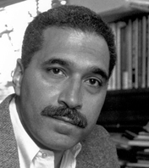
Shelby Steele is a research fellow at Stanford University’s Hoover Institution, where he specializes in the study of race relations and affirmative action. In 2006, Steele received the Bradley Prize for his contributions to the study of race in the United States. Getty Images
The Supreme Court narrowly approved affirmative action in the 1978 Bakke case. But it left many unanswered questions. Is affirmative action a form of reverse discrimination? Which groups should receive preferential treatment in hiring and school admissions? And for how long? In 1996, these questions were put before California voters in the form of Proposition 209, which stated,

The state shall not discriminate against, or grant preferential treatment to, any individual or group on the basis of race, sex, color, ethnicity, or national origin in the operation of public employment, public education, or public contracting.
Proposition 209 was approved by 54 percent of the voters. In other states, however, the debate over affirmative action continues. Here are two contrasting perspectives on this issue.

Shelby Steele: Affirmative Action Hurts African Americans
African American scholar Shelby Steele has studied the benefits and drawbacks of affirmative action programs. Such programs, he notes, are motivated by good intentions. “Yet good intentions can blind us to the effects they generate when implemented.” In a 1990 article, he wrote, I think one of the most troubling effects of racial preferences for blacks is a kind of demoralization [discouragement]. Under affirmative action, the quality that earns us preferential treatment is an implied inferiority. However this inferiority is explained—and it is easily enough explained by the myriad deprivations that grew out of our oppression—it is still inferiority . . . In integrated situations in which blacks must compete with whites who may be better prepared, these explanations may quickly wear thin.

Steele believes that affirmative action encourages blacks to focus on their past sufferings as victims of racism rather than their strengths:

Like implied inferiority, victimization is what justifies preference, so that to receive the benefits of preferential treatment one must, to some extent, become invested in the view of oneself as a victim. In this way, affirmative action nurtures a victim-focused identity in blacks and sends us the message that there is more power in our past suffering than in our present achievements.

In addition, Steele argues that affirmative action fosters the illusion that helping blacks with preferential treatment can make up for past wrongs:

This logic overlooks a much harder . . . reality, that it is impossible to repay blacks living today for the historic suffering of the race. If all blacks were given a million dollars tomorrow it would not [compensate] . . . for three centuries of oppression that we still carry today . . .Suffering can be endured and overcome, it cannot be repaid. To think otherwise is to prolong the suffering.
—Shelby Steele, “A Negative Vote on Affirmative Action,” The New York Times Magazine, May 13, 1990
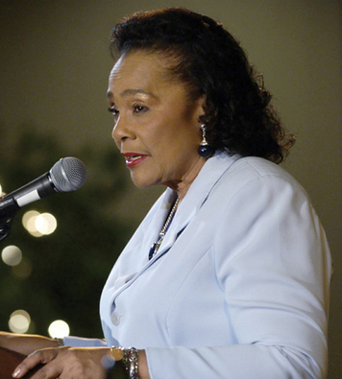
After her husband’s death, Coretta Scott King campaigned successfully for a national holiday honoring the civil rights leader. “This is not a black holiday,” she wrote, “it is a people’s holiday. And it is the young people of all races and religions who hold the keys to the fulfillment of his dream.” John Severson, The Indianapolis Star/AP Photo

Coretta Scott King: Affirmative Action Promotes Justice
During the debate over Proposition 209, Coretta Scott King, the widow of Martin Luther King Jr., wrote an article opposing the measure. She began by explaining her husband’s support for affirmative action.
He did indeed dream of a day when his children would be judged by the content of their character, instead of the color of their skin.But he often said that programs and reforms were needed to hasten the day when his dream of genuine equality of opportunity—reflected in reality, not just theory—would be fulfilled.

King went on to explain why affirmative action was still needed, more than three decades after such programs began:
Those who say that affirmative action is no longer necessary rarely cite statistics to support their argument, for the evidence of continuing pervasive discrimination against minorities and women is overwhelming. Indeed, statistics . . . testify to how precarious our hold is on equal opportunity and how discrimination in our society persists.
Like my husband, I strongly believe that affirmative action has merit, not only for promoting justice, but also for healing and unifying society.
—Coretta Scott King, “Man of His Word,” New York Times, November 3, 1996

Summary
The civil rights movement changed course in the mid-1960s, moving beyond the South and expanding its goals. Some activists also abandoned the strategy of nonviolence.
Black power In 1966, civil rights activists began calling for black power. They wanted African Americans to have economic and political power, as well as pride in their African heritage.
Watts riot In the summer of 1965, the Watts section of Los Angeles exploded in violence. This event was followed by riots in black ghettos across the nation.
Kerner Commission This commission, established by Lyndon Johnson to study the riots, concluded that their fundamental cause was pent-up resentment over historic inequalities.
Nation of Islam Also called Black Muslims, the Nation of Islam advocated black nationalism. Its members believed that blacks should live apart from whites and control their own communities.
Black Panther Party The Black Panther Party demanded economic and political rights. Unlike nonviolent civil rights leaders, the Black Panthers were prepared to fight to realize their goals.
Civil Rights Act of 1968 The most important clause in this law bans discrimination in the sale, rental, and financing of housing based on race, religion, national origin, or sex.
Swann v. Charlotte-Mecklenburg Board of Education In this decision, the Supreme Court ruled that busing is an acceptable way to achieve school integration.
Regents of the University of California v. Bakke In its first case on affirmative action, the Supreme Court ruled that race may be used as one, but not the only, factor in school admissions.

